First attempt

Simple R code
a <- 10b <- 20myVec <- rnorm(5)a + b
## [1] 30
range(myVec)
## [1] 0.5571 1.9197
Now test if it will write text within the document, the sum of the above analysis is 30.

Creating a plot
plot(1:10, col = "red")
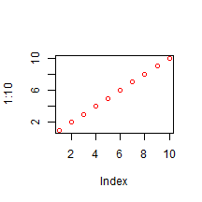
plot of chunk simpleplot

Conclusion
Isn't that grand and super.

