Spatial maps and geocoding in R
Install packages
install.packages("mapproj")install.packages("ggmap")install.packages("DeducerSpatial")
load packages
require(maps)require(ggmap)

Using the maps package
par(mfrow = c(2, 1))map("usa")
plot of chunk USA
map("county")
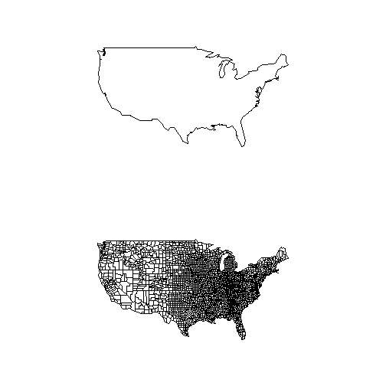
plot of chunk USA
map("world", "China")map.cities(country = "China", capitals = 2)
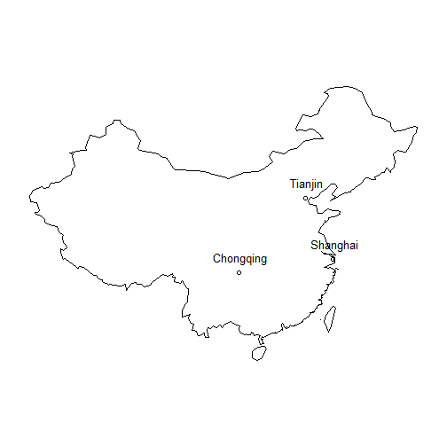
plot of chunk china
map("state", "GEORGIA")data(us.cities)map.cities(us.cities, country = "GA")
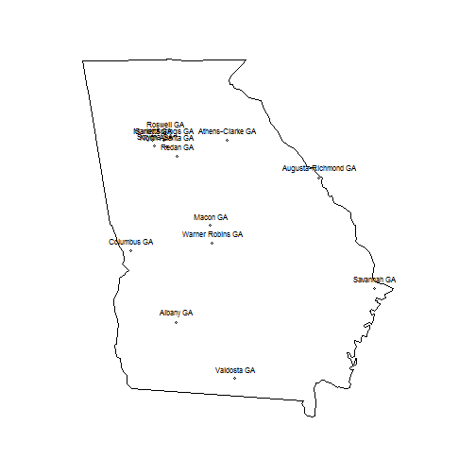
plot of chunk states
Plot the unemployment in each county
data(unemp)data(county.fips)# Plot unemployment by countrycolors = c("#F1EEF6", "#D4B9DA", "#C994C7", "#DF65B0", "#DD1C77", "#980043")head(unemp)
## fips pop unemp## 1 1001 23288 9.7## 2 1003 81706 9.1## 3 1005 9703 13.4## 4 1007 8475 12.1## 5 1009 25306 9.9## 6 1011 3527 16.4
head(county.fips)
## fips polyname## 1 1001 alabama,autauga## 2 1003 alabama,baldwin## 3 1005 alabama,barbour## 4 1007 alabama,bibb## 5 1009 alabama,blount## 6 1011 alabama,bullock
unemp$colorBuckets <- as.numeric(cut(unemp$unemp, c(0, 2, 4, 6, 8, 10, 100)))colorsmatched <- unemp$colorBuckets[match(county.fips$fips, unemp$fips)]map("county", col = colors[colorsmatched], fill = TRUE, resolution = 0, lty = 0, projection = "polyconic")# Add border around each Statemap("state", col = "white", fill = FALSE, add = TRUE, lty = 1, lwd = 0.2, projection = "polyconic")title("unemployment by county, 2009")leg.txt <- c("<2%", "2-4%", "4-6%", "6-8%", "8-10%", ">10%")legend("topright", leg.txt, horiz = TRUE, fill = colors)
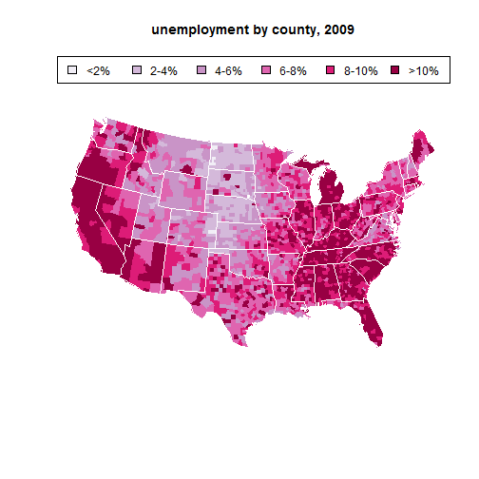
plot of chunk jobs

Using OpenStreetMaps
OpenStreetMap is a new package that accesses raster open street maps from Mapnik, and satellite imagery from Bing.
Some features: - Uses multiple map tiles stitched together to create high quality images. - No files are created or stored on the hard drive. - Tiles are cached, so downloads occur only when necessary. - ggplot 0.9.0 integration
More information is available at: http://blog.fellstat.com/?p=130

Deducer
DeducerSpatial is a package for spatial data analysis which includes the ability to plot and explore open street map and Bing satellite images.
```{Deducer} library(UScensus2000)
lat <- c(43.834526782236814,30.334953881988564) lon <- c(-131.0888671875 ,-107.8857421875) southwest <- openmap(c(lat[1],lon[1]),c(lat[2],lon[2]),5,'bing') data(california.tract) california.tract <- spTransform(california.tract,osm())
plot(southwest,removeMargin=TRUE) choro_plot(california.tract,dem = slot(california.tract,"data")[,'med.age'], legend.title = 'Median Age',alpha=1)
Using the ggmap package===================================Maps are extracted from Google Maps, OpenStreetMap, or Stamen Maps server for a map. You can query the Google Maps, OpenStreetMap, or Stamen Maps server for a map at a certain location at a certain spatial zoom. geocode=========The geocode function will extract the position (latitude and longtitude) of a location using Google Maps```{geocode}> geocode('CDC') lon lat1 -84.3258 33.7988> geocode('Baylor University') lon lat1 -97.11332 31.54641> geocode('the white house', messaging = TRUE)contacting http://maps.googleapis.com/maps/api/geocode/json?address=the+white+house&sensor=false... done. lon lat1 -77.03282 38.89521> geocode(c('baylor university', 'CDC'), output = 'latlona') lon lat1 -97.11332 31.546412 -84.32580 33.79880 address1 baylor university, 1311 s 5th st, waco, tx 76706, usa2 centers for disease control and prevention, 1600 clifton rd ne, atlanta, ga 30329, usa> geocode(c('harvard university', 'the vatican'), output = 'more') lon lat type loctype1 -71.11847 42.37315 point_of_interest approximate2 12.45813 41.90226 locality approximate address1 harvard university housing office, 1350 massachusetts ave, cambridge, ma 02138, usa2 00120 vatican city north south east west postal_code country1 42.38139 42.36490 -71.10246 -71.13447 02138 united states2 41.90747 41.73199 12.66542 12.44584 00120 vatican city administrative_area_level_2 administrative_area_level_1 locality1 middlesex massachusetts cambridge2 <NA> <NA> vatican city street streetNo point_of_interest1 massachusetts ave 1350 harvard university housing office2 <NA> NA <NA>

Exercise
```{Exercise} Get the geocode for the eiffel tower. Is there a unique map?
geocode('the eiffel tower', output = 'all') ```

mapdist
{mapdist} mapdist(from, to, mode = c("driving", "walking", "bicycling"), output = c("simple", "all"), messaging = FALSE, sensor = FALSE, language = "en-EN", override_limit = FALSE)
Example, how far is it to walk from the CDC to the white house and map the route.
```in{mapdistCDC} > mapdist('CDC', 'the white house', mode = 'walking')
from to m km miles seconds minutes
1 the white house CDC 1019454 1019.454 633.4887 731359 12189.32 hours 1 203.1553 ```
Google Geocoding API is subject to a query limit of 2,500 geolocation requests per day
{GoogleCheck, eval=FALSE} geocodeQueryCheck()

Study of crimes in Houston
Extract location of crimes in houston
violent_crimes <- subset(crime, offense != "auto theft" & offense != "theft" & offense != "burglary")# rank violent crimesviolent_crimes$offense <- factor(violent_crimes$offense, levels = c("robbery", "aggravated assault", "rape", "murder"))# restrict to downtownviolent_crimes <- subset(violent_crimes, -95.39681 <= lon & lon <= -95.34188 & 29.73631 <= lat & lat <= 29.784)
Map these crimes on the map of the city
{crimes, eval=FALSE} HoustonMap <- qmap('houston', zoom = 14,color = 'bw', legend = 'topleft') HoustonMap +geom_point(aes(x = lon, y = lat, size = offense,colour = offense), data = violent_crimes )
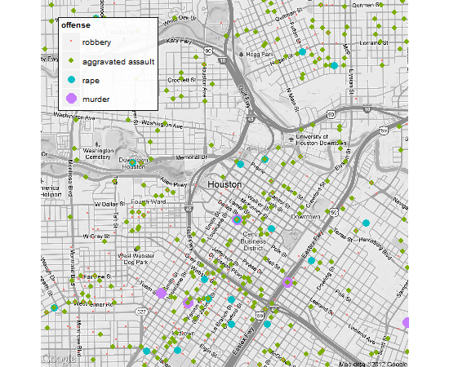 Results of qmap using ggmap of crimes in houston
Plot again but use stats$_$denisty layer ```{crimes2, eval=FALSE} houston <- get_map('houston', zoom = 14) HoustonMap <- ggmap(houston, extent = 'device', legend = 'topleft')
HoustonMap + stat_density2d(aes(x = lon, y = lat, fill = ..level.. , alpha = ..level..),size = 2, bins = 4, data = violent_crimes, geom = 'polygon') scale_fill_gradient('Violent') + scale_alpha(range = c(.4, .75), guide = FALSE) + guides(fill = guide_colorbar(barwidth = 1.5, barheight = 10)) ```
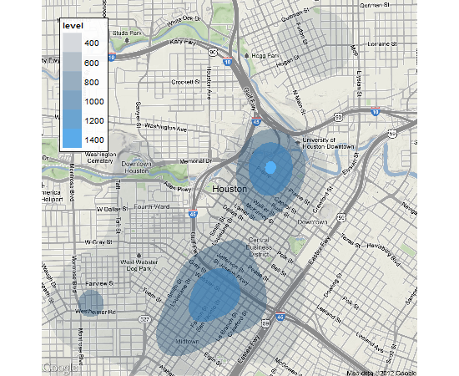 Results of qmap using ggmap of crimes in houston
Add the colorbar guide to the key
{crimes3,eval=FALSE} HoustonMap + stat_density2d(aes(x = lon, y = lat, fill = ..level.., alpha = ..level..), size = 2, bins = 4, data = violent_crimes, geom = 'polygon') +scale_fill_gradient('Violent\nCrime\nDensity') +scale_alpha(range = c(.4, .75), guide = FALSE) +guides(fill = guide_colorbar(barwidth = 1.5, barheight = 10))
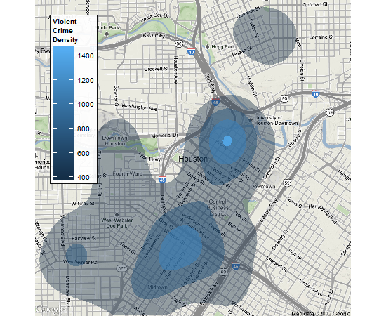 Results of qmap using ggmap of crimes in houston
sessionInfo()
## R version 2.15.1 (2012-06-22)## Platform: i386-pc-mingw32/i386 (32-bit)## ## locale:## [1] LC_COLLATE=English_United States.1252 ## [2] LC_CTYPE=English_United States.1252 ## [3] LC_MONETARY=English_United States.1252## [4] LC_NUMERIC=C ## [5] LC_TIME=English_United States.1252 ## ## attached base packages:## [1] grid splines stats graphics grDevices utils datasets ## [8] methods base ## ## other attached packages:## [1] knitr_0.6.3 DeducerSpatial_0.4 OpenStreetMap_0.2 ## [4] raster_2.0-05 maptools_0.8-14 sp_0.9-99 ## [7] Deducer_0.6-3 plyr_1.7.1 foreign_0.8-50 ## [10] effects_2.1-1 colorspace_1.1-1 lattice_0.20-6 ## [13] multcomp_1.2-12 survival_2.36-14 mvtnorm_0.9-9992 ## [16] car_2.0-12 nnet_7.3-1 MASS_7.3-18 ## [19] JGR_1.7-9 iplots_1.1-4 JavaGD_0.5-5 ## [22] scales_0.2.1 rJava_0.9-3 mapproj_1.1-8.3 ## [25] maps_2.2-6 ggmap_2.1 ggplot2_0.9.1 ## ## loaded via a namespace (and not attached):## [1] dichromat_1.2-4 digest_0.5.2 evaluate_0.4.2 ## [4] formatR_0.5 labeling_0.1 memoise_0.1 ## [7] munsell_0.3 parser_0.0-15 png_0.1-4 ## [10] proto_0.3-9.2 RColorBrewer_1.0-5 Rcpp_0.9.11 ## [13] reshape2_1.2.1 RgoogleMaps_1.2.0 rjson_0.2.8 ## [16] stringr_0.6 tools_2.15.1

